TIP: Visit www.giftcardsonsale.com.au to find iTunes Cards on sale and save on apps.
This list of apps is for students from Years 5‐8. Some apps will be retained from Junior School. Unless specified for a particular year level all apps should be added to your child’s iPad and will be used at different times throughout their time in Middle School.

 | A+ Spelling Test  Spelling activities. | FREE | 20.6MB
 | Apple Books  Formerly iBooks. Download, read and maintain a synchronised library of books across all devices. Needed to download texts and novels. | FREE | 31.0MB
 | Book Creator for iPad  Create interactive books with text, images, audio and video. | $5.99 | 188.1MB
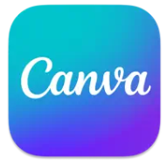 | Canva: Design, Photo & Video  Make logos, posters & collages. | FREE | 166.3MB
 | Comic Life 3  Create comics using photos, speech bubbles, templates etc. | $7.99 | 106.7MB
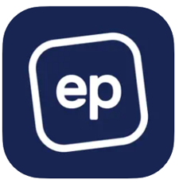 | Education Perfect (EP Student)  Online program used across a number of key learning areas. | FREE | 7.4MB
 | ePlatform  Provides access to borrow some digital resources such as eBooks from the library. | FREE | 45.9MB
 | Google Earth  Interactive globe atlas with 3D constructions, photographs etc. | FREE | 312.0MB
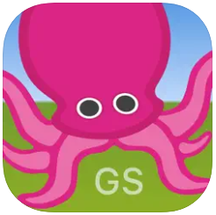 | Green Screen by Do Ink  Create incredible green screen videos and images. | $7.99 | 58.9MB
 | HelloChinese ‐ Learn Chinese  Interactive games and videos to support the learning of the Mandarin language. | FREE | 151.2MB
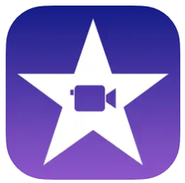 | iMovie  Movie production. | FREE | 694.4MB
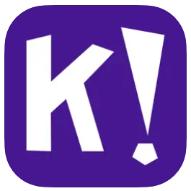 | Kahoot!  Creates quizzes, games and surveys. | FREE | 93.5MB
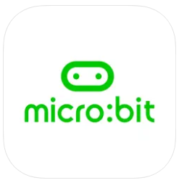 | micro:bit  Interface for programming micro:bits. | FREE | 51.5MB
 | Microsoft 365  The 365 app combines the Word, Excel and PowerPoint apps to be able to create word documents, spreadsheets and presentations from a single app. | FREE | 412.5MB
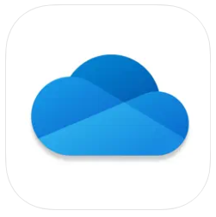 | Microsoft OneDrive  Keeps your files and photos backed up and protected, synced and accessible on multiple devices using individuals OACC Microsoft 365 1TB of storage. | FREE | 354.2MB
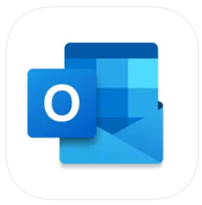 | Microsoft Outlook  Secure Email, Calendar & Files. Outlook lets you bring all your email accounts and calendars in one convenient spot. | FREE | 328.3MB
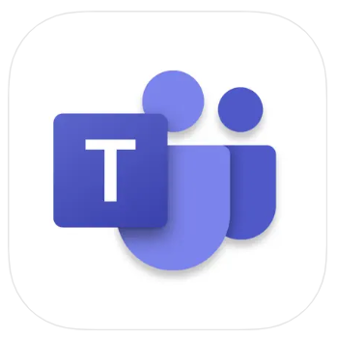 | Microsoft Teams  Hub for online teamwork, video conferencing, calling and content collaboration. | FREE | 340.0MB
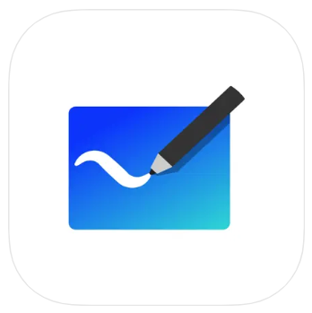 | Microsoft Whiteboard  Your digital smartboard. | FREE | 35.5MB
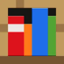 | Minecraft Education  3D building. | FREE | 1.1GB
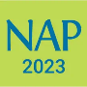 | NAP Locked down browser  Locked down browser for access to the Online National Assessment Platform | FREE | 69.8MB
 | PicCollage  Creates collages with photos. Includes backgrounds and templates. | FREE | 167.2MB
 | Quizlet  Supports study of concepts from almost any subject. | FREE | 176.1MB
 | ScratchJr  Coding and programming. | FREE | 53.8MB
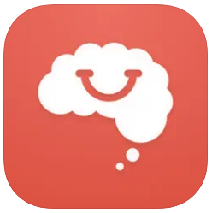 | Smiling Mind  A meditation tool. | FREE | 41.8MB
 | SPARKvue  SPARKvue is a popular data collection, visualization and analysis application for STEM learning. | FREE | 193.1 MB
 | StaffWars  Helps beginning and intermediate musicians learn and practice the note names of the treble, alto and bass clefs. | $1.99 | 32.0MB
 | Superbook Kids Bible  This app has a full Bible with videos, images and interactive content embedded in each chapter of the Bible. | FREE | 151.4MB
 | Swift Playgrounds  Coding app. Students learn and experiment with code and create programs. | FREE | 838.7MB
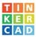 | Tinkercad  Tinkercad is a free collection of tools that help people all over the world make anything. | FREE | 22.4MB

Additional Apps Specific to a Year Level

 | GarageBand  Fully functional recording studio with touch instruments for producing podcasts and compositions. | FREE | 1.7GB | For Year 5
 | iThrass  Digital format THRASS PICTURE CHART for accessing the 44 phonemes of spoken English and the 120 most common graphemes of written English. | $19.99 | 77.8MB | For Year 5 and 6
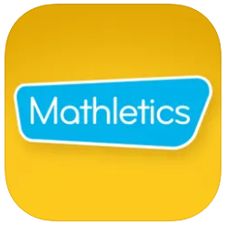 | Mathletics Students  This app is a companion tool for Mathletics. Students are able to engage in curriculum‐aligned activities through a range of learning experiences and in‐app assessments. | FREE | 20.1MB | For Year 5 and 6
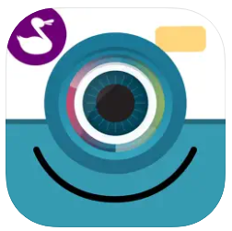 | ChatterPix  Support the learning of the Mandarin language by making anything come to life and talk. | FREE | 79MB | For Year 6 and 7
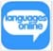 | Languages Online  Students learn to speak, read and write key vocabulary. Engaging topics, flashcards, activities, games and songs. Students can voice record. | FREE | 35.6MB | For Year 7 and 8 Indonesian students

Total Size
Year 5 = 8.5GB approx | Year 7 = 6.4GB approx
Year 6 = 6.9GB approx | Year 8 = 6.3GB approx

NOTE: Students in Years 5 to 8 require an iPad or iPad Pro running iOS14.0 or later. If purchasing a new iPad, please do not purchase an iPad Mini. iPads are to have a minimum of 32GB of storage. WiFi only.

